EV Charging Station Demand Analysis

1. Introduction and Problem Statement
The rapid growth of electric vehicles (EVs) has increased the need for efficient and well-planned charging infrastructure. Understanding charging demand patterns is essential for optimizing charging station placement, managing energy consumption, and supporting sustainable transportation systems.
This project focuses on analyzing EV charging station usage data to identify meaningful patterns related to charging demand over time, location-based usage, user behavior, and energy consumption. The analysis aims to support data-driven decision-making for EV infrastructure planning.

2. Data Description
The dataset used in this project contains detailed records of EV charging sessions collected from multiple charging stations.

Dataset Characteristics:
- Total Records: ~1,300+ charging sessions
- Total Attributes: 20+ columns

Key Data Attributes:
- Charging Information: charging start time, charging end time, charging duration
- Energy Information: energy consumed (kWh), charging rate (kW), battery capacity
- Location Information: charging station ID, charging station location
- User Information: user type, vehicle model
- Additional Attributes: charger type, distance driven, temperature
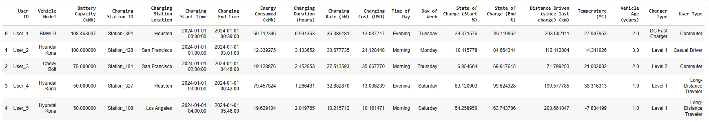

3. Data Cleaning and Preparation (Python)
Python was used as the primary tool for cleaning and preparing the dataset for analysis.

3.1 Initial Data Exploration
- Dataset loaded using Pandas
- Column data types and summary statistics reviewed
- Missing and inconsistent values identified

3.2 Handling Missing Values
- Records with missing values in critical fields such as energy consumed, charging rate, and distance driven were removed
- Only a small percentage of records (~5%) were affected, ensuring minimal data loss

3.3 Feature Engineering
To enhance analytical depth, new features were created:
- charging_hour, charging_day, charging_month, charging_year extracted from charging start time
- charging_weekday derived to analyze weekday trends
- peak_period classified into Peak and Off-Peak charging hours
- station_city extracted for location-based analysis

4. Exploratory Data Analysis (EDA & KPI Analysis)
Exploratory Data Analysis was performed to understand EV charging behavior and demand patterns. The following Key Performance Indicators (KPIs) were identified and analyzed:
- Which hours have the highest charging demand?
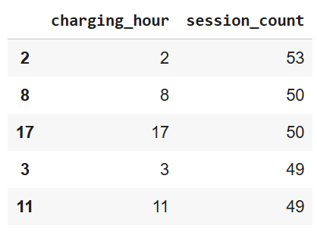
- Peak vs Off-Peak demand comparison
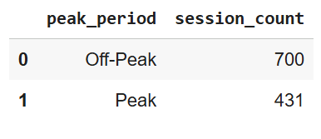
- Which cities have the highest EV charging demand?
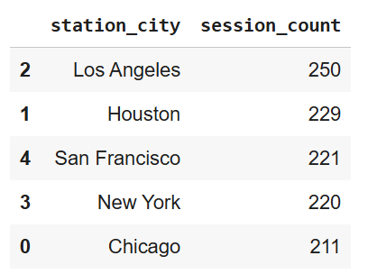
- Energy demand by city (kWh)
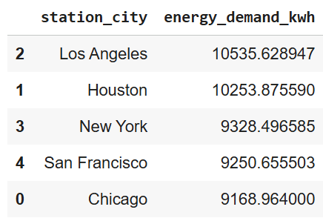
- Weekday vs Weekend charging behaviour
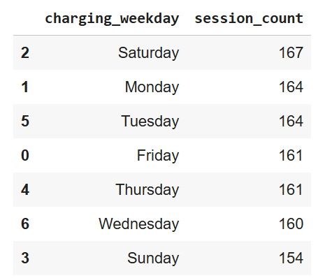
- Demand by user type
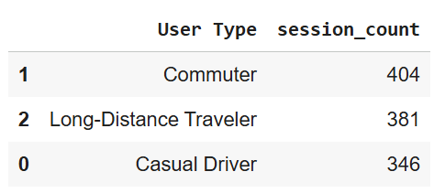
- Charger type utilization
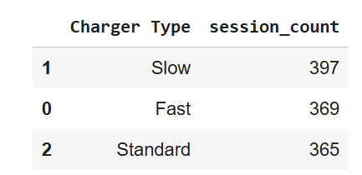
- onthly demand trend (Time-Series
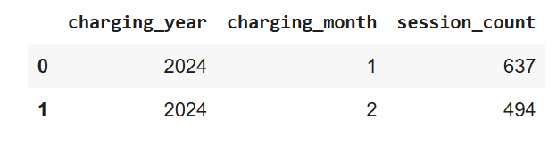

5. Data Visualization and Dashboard (Power BI)
An interactive dashboard was developed using Power BI to visually communicate insights to non-technical stakeholders.
The dashboard includes KPI cards, time-based demand charts, location-wise analysis, and user behavior insights, enabling effective monitoring and decision-making.
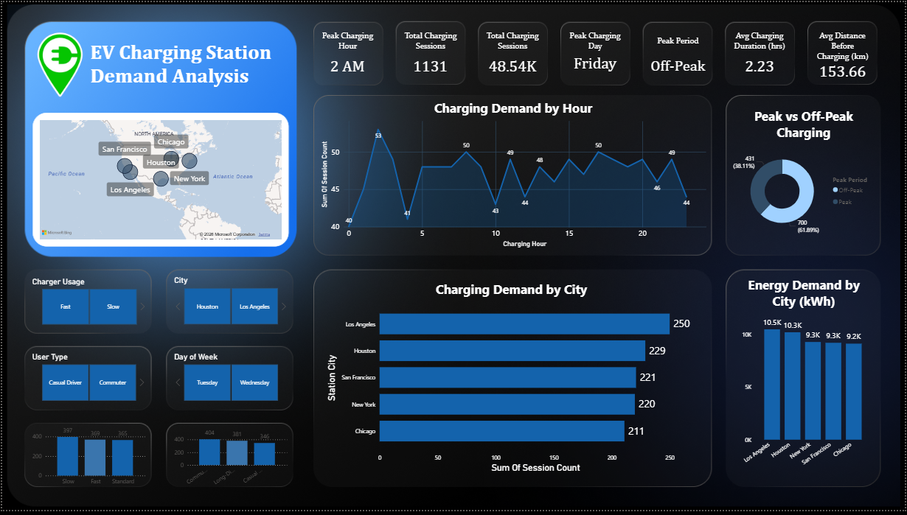

6. Key Insights and Business Recommendations

Insights:
- Off-Peak charging sessions dominate overall usage
- Early morning hours show the highest charging demand
- Los Angeles and Houston are the highest-demand cities
- Energy consumption is strongly correlated with charging session volume
- Commuters represent the largest user group
- Slow chargers are the most frequently used charger type

Recommendations:
- Expand charging infrastructure in high-demand cities
- Encourage off-peak charging through pricing incentives
- Increase fast charger availability in high-energy-demand locations
- Use demand trends for future EV infrastructure planning
- Optimize charger mix based on user behavior

7. Conclusion
This project demonstrates how EV charging station data can be transformed into actionable insights using Python for data cleaning, feature engineering, and demand analysis, along with Power BI for interactive visualization. The analysis highlights real-world infrastructure analytics skills relevant to data analyst and business analyst roles, particularly in the sustainability and EV domain.

8. Tools and Technologies Used
- Python (Pandas, NumPy, Matplotlib, Seaborn)
- Google Colab
- Power BI
- CSV Dataset (EV Charging Data)

9. Disclaimer
This project report is created for academic and portfolio purposes using publicly available data. The analysis does not represent official EV charging network metrics and is intended solely for learning and demonstration purposes.

